There isn’t really one reason why this is the official color of St. Patrick’s day, but the color green has a lot of connections to Ireland and springtime. It’s featured in the Irish flag, Ireland is nicknamed the “Emerald Isle”, it represents spring and it’s the color of shamrocks.

I interviewed some students and a teacher and asked them what they think about St. Patrick’s Day

Why Do We Wear Green on St. Patrick’s Day?

Lighthouse Times

Issue

03

**March**

**2016**

I asked do you believe in St. Patrick’s Day and they both said yes. I asked do you like getting pinched on St. Patrick’s Day and they said no. I also asked do you celebrate St. Patrick’s Day and they both said yes. Also asked if they wear green and they said yes and finally I asked if they believe leprechauns made St. Patrick’s Day and they said no.

I asked Ms. Ashley why she thinks St. Patrick’s Day is a holiday and she replied “because people with Irish heritage wanted a way to pass on their beliefs in other countries and to keep their culture alive even though they migrated to other countries”. I also asked both Danielle and Austin J. questions about St. Patrick’s and here is the questions.

**By Celebritty**

People thought wearing green made one invisible to leprechauns, fairy creatures who would pinch anyone they could see (anyone not wearing green). People began pinching those who didn’t wear green as a reminder that leprechauns would sneak up and pinch people who weren’t wearing green.

March Birthdays

* Cheyenne
* Martisha
* Alexus
* Marke’a
* Jaquan
* Ky’asha
* Mr. G
* Ms. Debbie

Important Dates

* March 28-April 1 is SPRING BREAK!
* OGT Testing March 14-25
* AIR Testing April 11-15
* Dr. Greenfield comes every Tuesday

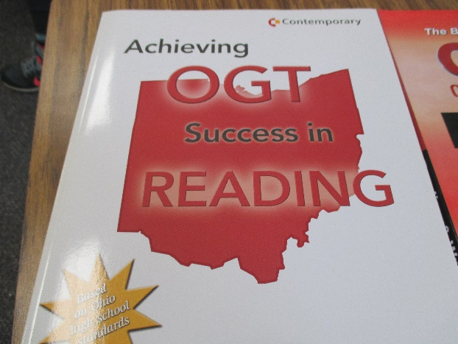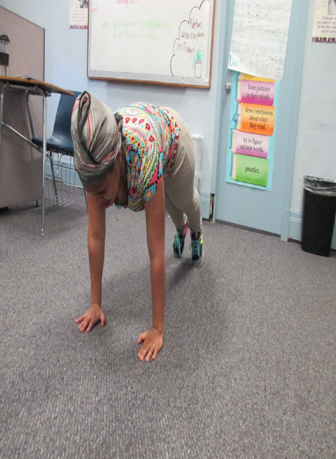

**By Danielle**

This month’s teacher feature is Mr. Paul. As you all know Mr. Paul and his wife just had a beautiful baby boy January 13, 2016. Mr. Paul and his wife name their son Neal Schick. As I interviewed Mr. Paul he said since the baby has been born he’s got very little sleep, but having a baby is wonderful and wouldn’t trade him for the world.

“I love being a father.” Said Mr. Paul.

Mr. Paul said in the interview that he loved his family and his life. He loves running, hiking, fixing his house, playing with baby Neal, and being outside.

Mr. Paul always knew he was going to be a teacher growing up he said.

Mr. Paul is our science teacher and chose to be a science teacher because it’s his favorite subject and he loves doing experiments, but he wanted to become a teacher overall to make a difference.

He enjoys working with urban students he said.

“He’s a good teacher, he’s cool, he’s understanding, and I love him.” Said Austin Johnson.

“My goals for students at LCS is for them to believe in themselves, and to find them a successful life that makes them happy.” Said Mr. Paul.

Teacher Feature: Mr. Paul

Here are some tips from Ms. Dionne about the testing. She said you must carefully read the questions. She said, “If you want to prepare for the test, you should study.” She also said, if you fail the test you will have to study harder and then retake the test.

Then I interviewed Ms. Rebecca about test taking. Her first bit of advice was to get prepared for the test by taking deep breathes. The she said to eat or chew mints or listen to soothing music. “You should study the material or take a practice test or make flash cards to get prepared for the test,” said Ms. Rebecca.

Good luck to all LCS students on your upcoming state tests!

**By: Darryl**

In the next few weeks, all students will be taking the state tests. Some student will take the OGT’s while others will take the new AIR tests. Test taking can be stressful, but here are some tips on test taking.

**Test taking Dates:**

* **OGTS- March14-25**
* **AIR Assessments- April 11- 15**

When I interviewed teachers about the test taking this is what they said.

Mr. Paul said, “There are plenty of chances to take the test.” Then he said to get prepared for the test students should get plenty of sleep. He said if you pass the state test you will graduate. Then he said, “If you don’t pass you will have to retake the test until you pass the test.” Students should be able to complete a practice test and feel like they did well.

Lighthouse Community School

6100 Desmond Street

Cincinnati, OH

**Test Taking Tips from LCS Teachers**

this issue

State Testing P.1

Student of the Month P.2

**Exercise Tips**  P.3

**St. Patrick’s Day**P.4

**Spring Break Activities**

**By Austin**

For spring break, all of our fellas should take our special someone out on dates. Spring is the best time to have a thing.

If we were older we could go on a vacation, that’s a good spring break activity for older folk. There is too much to do to just stay in the house or go to the movies all the time.

A good list of places are the following; the movies, any restaurants available, mini golfing, laser tag and bowling. Sky zone is always fun and go roller skating. Walks in the park won’t hurt here and there either. If you are really about the action go paint balling. Full throttle go karting is a fun thing too. Have a fun and safe spring break.

I asked Danielle what is her favorite subject and who is her teacher.

Her favorite blue, green, orange and yellow. Her favorite thing to do in her free time is play basketball.

When I asked who should be student of the month for April, she said, “Somebody who has been doing good and got good grades.”

I asked Ms. Rebecca a few questions also about Danielle becoming student of the month. She thinks that Danielle is a good person, that she is funny, caring and outspoken.

To Danielle, Ms. Rebecca said, “Keep up the good job and your hard work will pay off in the end.”

**Austin Fetters**

**By Austin J.**

Austin Fetters is student of the month. In December he will be 17. His birthday is December 5th. He is from Dayton, Ohio. In his free time he enjoys listening to music. Austin’s favorite subject in school is gym and science. His favorite food is pizza.

When I asked him what he thought about being student of the month he said, “I like it.”

I asked Austin how his year was going so far and he said, “It’s going pretty good for real”

Mr. Paul said that “Austin asks very good questions in class, very prospering and intuitive, good people”

Congratulations Danielle And Austin Fetters!

What does it take to be an LCS student of the month? Hard work in the classroom, good behavior and a positive attitude! Student of the Month are working hard to follow all the LCS Core Values.

**What’s Up Around LCS?**

**By Kayla**

This is for all those who skip class to see what other classes are doing. Let me save you a trip. Here is what the students are working on in other classes.

In Ms. Ashley’s class, they are reading “*To Kill A Mockingbird.”* I interviewed one the students in 5th bell English and they said they don’t like the book because it’s racist, “Tom Robinson got sent to jail because he was black,” said Danielle.

In math they are learning geometry and how to find area. The students said it’s not hard because Mr. Peter explains the steps very well. They have to remember the phrase “base times height “as in 4*8=Area.

If you are wondering what’s going on in history, no need to interrupt another class. In World History they’re learning about WWII. They don’t like the subject because it’s boring and don’t think they benefit from it.

In art they’re working on Black History. Each student is working on a different leader like Nelson Mandela. They getting to know what they did for us as black people and what they sacrificed.

In computer class they are doing typing test to see who types the fast. Right now Kyran’s score is 60 words per minute.

So that’s a quick review of your school. Now there’s no excuses to miss class. So be in the right place at the right time

* Find a convenient time and place
* Choose activates that are fun not exhausting , and variety
* Use music or audio books to keep you entertained
* Use variety to keep your interest up , walk one day , swim the next day then go for a bike ride on the weekend
* Loose-fitting clothing appropriate for the weather
* Try to make it a habit
* Don’t exercise too vigorously right after a meal, or when it’s hot or humid
* Ask a friend or a family member to join you
* Note your activities on a calendar or logbook

**This month exercises are jumping jacks, squats and pushups. Check out these activities in the gym.**

**Danielle Abbott**

**By Celebritty**

Danielle Abbot is Student of the Month for March. I interviewed Danni and asked her questions on how she feels about being student of the month and personal things that she does for fun.

After hearing that Danielle was the student of the month, I asked if she was excited and how she felt about being named March Student of the Month.

She said, “Yes… it doesn’t really bother me.”

I asked what advice she has for students who wish to become student of the month. She says to stay on your game and stay out of drama.

She says, “My favorite subject is math and my favorite teacher is Mr. Paul.”

I asked what she likes about Lighthouse. She says it’s a decent school and, “I get my work done, with good grades.”

**Students of the Month**

I am writing about exercise to help out students to LCS and I hope you can use them and they help you out

* Be consistent
* Wear comfortable properly fitted sneakers or flat shoes with laces
* Start slowly gradually build up at least 30 minutes of activity
* Exercise at the same time of the day so it becomes a regular part of your lifestyle

**By Sara**

Exercise Tips and Tricks